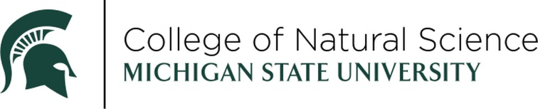
ALUMNI SERVICE AWARD
NOMINATION FORM

The Alumni Service Award is presented to distinguished alumni who have demonstrated exceptional service and/or philanthropy to our community. This prestigious honor recognizes individuals who have gone above and beyond in their dedication to making a positive impact through volunteerism, leadership, and charitable contributions. Nominees must be an alum of the Michigan State University College of Natural Science.

NOMINEE:
CAMPUS ADDRESS:
OFFICE TELEPHONE (IF KNOWN):
EMAIL:
MSU DEPARTMENT(S):
CURRENT ROLE, ORGANIZATION:

PLEASE ADDRESS THE FOLLOWING (ON A SEPARATE PAGE):
- Describe the nominee’s service or philanthropy to our community.
- Describe the impact the nominee’s service or philanthropy has had on Michigan State University.
- Describe the nominee’s impact through volunteerism, leadership or charitable contributions.

The above information should be no longer than one (1) page in length TOTAL.

THIS NOMINATION SUBMITTED BY:
NAME:
COMPANY/ORGANIZATION/INSTITUTION:
EMAIL:
DAYTIME TELEPHONE:
SUPPORTING DOCUMENTATION:
- Nominee’s CV
- Any additional supporting documentation supporting the nomination i.e. journal article on current research, newspaper citation for community service or philanthropy. Additional supporting documentation is not required, but may be helpful in assessing the nomination.

RETURN NOMINATION FORM AND SUPPORTING DOCUMENTATION TO DRAEGER3@MSU.EDU.

All submissions should be emailed to Melody Vincke (draeger3@msu.edu). Submissions will receive a confirmation of receipt within two days. If you do no receive any confirmation, please contact Melody to make sure the email was received.

The winner will be celebrated at an in-person awards ceremony in April 2027.

NOMINATIONS MUST BE RECEIVED BY FRIDAY, SEPTEMBER 25, 2026.

Questions? Contact Melody Vincke, draeger3@msu.edu.

