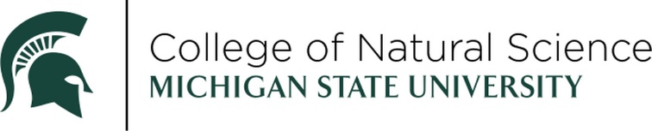

MERITORIOUS FACULTY AWARD

NOMINATION FORM



The Meritorious Faculty Award is presented to a faculty member who has demonstrated excellence in the areas of both teaching and research. Nominees must have an appointment (full or partial) in the College of Natural Science. Recipients exemplify Michigan State University’s commitment to the land-grant mission of teaching, research and outreach through their dedication to professional, community and/or MSU service.

NOMINEE:

CAMPUS ADDRESS:

OFFICE TELEPHONE (IF KNOWN):

EMAIL:

MSU DEPARTMENT(S):

PLEASE ADDRESS THE FOLLOWING (ON A SEPARATE PAGE):

1. Describe the nominee’s contributions in the field of science.
2. Describe the impact the nominee’s teaching has had on MSU students, and the involvement of students in their research.
3. Describe the nominee’s professional and/or societal community involvement and exceptional MSU service work.

*The above information should be no longer than one (1) page in length TOTAL.*

THIS NOMINATION SUBMITTED BY:

NAME:

COMPANY/ORGANIZATION/INSTITUTION:

EMAIL:

DAYTIME TELEPHONE:

SUPPORTING DOCUMENTATION:

* Nominee’s CV
* Any additional supporting documentation supporting the nomination i.e. journal article on current research, newspaper citation for community service. *Additional supporting documentation is not required but may be helpful in assessing the nomination.*

RETURN NOMINATION FORM AND SUPPORTING DOCUMENTATION TO:

EMAIL

[suttonj2@msu.edu](mailto:suttonj2@msu.edu)

*All email submissions will receive confirmation of receipt within two days. If you do not, please contact Jennifer to make sure the email was received.*

The winner will be celebrated at an in-person awards ceremony on Friday, April 10th, 2026.

NOMINATIONS MUST BE RECEIVED BY FRIDAY, SEPTEMBER 26, 2025.

Questions? Contact Jennifer Lindner, [suttonj2@msu.edu](mailto:suttonj2@msu.edu).