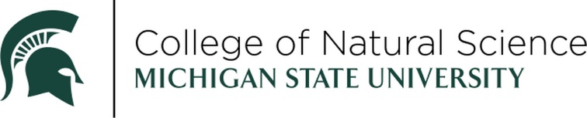

OUTSTANDING ALUMNI AWARD

NOMINATION FORM



The Outstanding Alumni Award recognizes Michigan State University College of Natural Science alumni who graduated more than 15 years ago. Recipients should show a commitment to the land-grant mission of advancing knowledge and transforming lives over the course of their career or lifetime. Nominees should possess exceptional professional achievements, valued contributions to society, and recognized support of the college or university.

NOMINEE:

DEGREE & YEAR:

ADDRESS:

CITY STATE ZIP:

HOME TELEPHONE (IF KNOWN):

EMAIL:

CURRENT TITLE:

COMPANY/ORGANIZATION/INSTITUTION:

PLEASE ADDRESS THE FOLLOWING (ON A SEPARATE PAGE):

1. Describe the nominee’s professional or career accomplishments.
2. Describe the nominee’s community involvement.
3. Identify any college or university support or service work.

*The above information should be no longer than one (1) page in length TOTAL.*

THIS NOMINATION SUBMITTED BY:

NAME:

COMPANY/ORGANIZATION/INSTITUTION:

EMAIL:

DAYTIME TELEPHONE

SUPPORTING DOCUMENTATION:

* Any additional supporting documentation supporting the nomination i.e. awards, journal article on current research, mention of community service. *Additional supporting documentation is not required, but may be helpful in assessing the nomination.*

RETURN NOMINATION FORM AND SUPPORTING DOCUMENTATION TO:

EMAIL

[suttonj2@msu.edu](mailto:suttonj2@msu.edu)

*All email submissions will receive a confirmation of receipt within two days. If you do not, please contact Jennifer to make sure the email was received.*

The winner will be celebrated at an in-person awards ceremony on Friday, April 10th, 2026.

NOMINATIONS MUST BE RECEIVED BY FRIDAY, SEPTEMBER 26, 2025.

Questions? Contact Jennifer Lindner, [suttonj2@msu.edu](mailto:suttonj2@msu.edu).