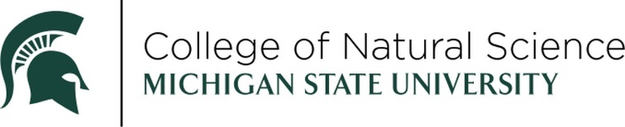

RECENT ALUMNI AWARD

NOMINATION FORM



The Recent Alumni Award recognizes Michigan State University alumni who have graduated within the last 15 years. The nominee should be a rising star showing early-career professional growth and achievement as well as making positive contributions to communities and / or impact on MSU beyond the classroom.

NOMINEE:

DEGREE & YEAR:

ADDRESS:

CITY STATE ZIP:

HOME TELEPHONE (IF KNOWN)

EMAIL:

CURRENT TITLE:

COMPANY/ORGANIZATION/INSTITUTION:

PLEASE ADDRESS THE FOLLOWING (ON A SEPARATE PAGE):

1. Describe the nominee’s professional accomplishments and/or impact on their profession.
2. Describe the nominee’s positive involvement in communities within and beyond the MSU campus since graduation.

*The above information should be no longer than one (1) page in length TOTAL.*

THIS NOMINATION SUBMITTED BY:

NAME:

COMPANY/ORGANIZATION/INSTITUTION:

EMAIL:

DAYTIME TELEPHONE:

SUPPORTING DOCUMENTATION:

* Any additional supporting documentation supporting the nomination i.e. awards, journal article on current research, mention of community service. *Additional supporting documentation is not required, but may be helpful in assessing the nomination*

RETURN NOMINATION FORM AND SUPPORTING DOCUMENTATION TO:

EMAIL

[suttonj2@msu.edu](mailto:suttonj2@msu.edu)

*All email submissions will receive a confirmation of receipt within two days. If you do not, please contact Jennifer to make sure the email was received.*

The winner will be celebrated at an in-person awards ceremony on Friday, April 10th, 2026.

NOMINATIONS MUST BE RECEIVED BY FRIDAY, SEPTEMBER 26, 2025.

Questions? Contact Jennifer Lindner, [suttonj2@msu.edu](mailto:suttonj2@msu.edu).