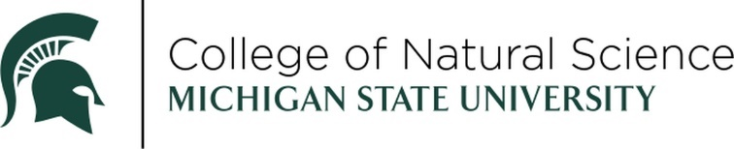
RECENT ALUMNI AWARD
NOMINATION FORM
The Recent Alumni Award recognizes Michigan State University alumni who have graduated within the last 15 years. The nominee should be a rising star showing early-career professional growth and achievement as well as making positive contributions to communities and / or impact on MSU beyond the classroom.

NOMINEE:
DEGREE & YEAR:
ADDRESS:
CITY STATE ZIP:
HOME TELEPHONE (IF KNOWN)
EMAIL:
CURRENT TITLE:
COMPANY/ORGANIZATION/INSTITUTION:

PLEASE ADDRESS THE FOLLOWING (ON A SEPARATE PAGE):
- Describe the nominee’s professional accomplishments and/or impact on their profession.
- Describe the nominee’s positive involvement in communities within and beyond the MSU campus since graduation.
The above information should be no longer than one (1) page in length TOTAL.

THIS NOMINATION SUBMITTED BY:
NAME:
COMPANY/ORGANIZATION/INSTITUTION:
EMAIL:
DAYTIME TELEPHONE:

SUPPORTING DOCUMENTATION:
- Nominee’s CV
- Any additional supporting documentation supporting the nomination i.e. awards, journal article on current research, mention of community service. Additional supporting documentation is not required, but may be helpful in assessing the nomination

RETURN NOMINATION FORM AND SUPPORTING DOCUMENTATION TO DRAEGER3@MSU.EDU.

All submissions should be emailed to Melody Vincke (draeger3@msu.edu). Submissions will receive a confirmation of receipt within two days. If you do no receive any confirmation, please contact Melody to make sure the email was received.

The winner will be celebrated at an in-person awards ceremony in April 2027.

NOMINATIONS MUST BE RECEIVED BY FRIDAY, SEPTEMBER 25, 2026.

Questions? Contact Melody Vincke, draeger3@msu.edu.

