Annual Performance Evaluation of Academic Specialists, Fixed Term Faculty, Tenure System Faculty

Instructions
Purpose & Process:
Unit leaders (chairs, directors, supervisors) are asked to review the performance of academic specialists and faculty annually “to help [them] grow and develop personally and to better help the unit, college and University accomplish its mission and objectives”. Per policy, this review must focus on “outcomes and behaviors”, and discuss methods and strategies for professional development and improvement. With this in mind, the college developed an Annual Evaluation Process for unit leader(s), academic specialists, and faculty to engage in direct and transparent conversations focused on expectations and goals at least once per year to strengthen alignment and mutual success. A single Annual Evaluation Form was designed to guide unit leaders as they evaluate the performance of academic specialists and faculty members in their unit. For additional information about the new NatSci Annual Evaluation Process and Form please watch this explanatory video.

The NatSci Annual Evaluation Process includes the following steps (steps 2-4 as in the figure):
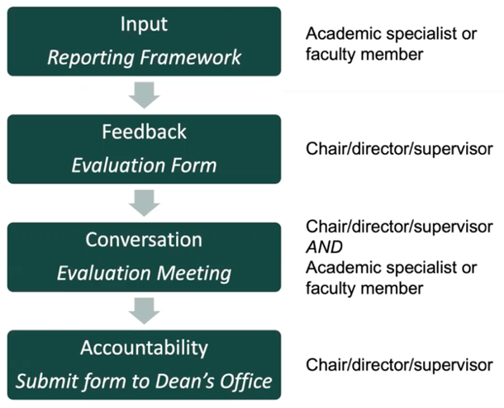
- Expectations. Unit sets goals, expectations, and process for the annual performance review (Reporting Framework, part 1)
- Input. Academic specialists and faculty submit materials for performance evaluation such as an Annual Reflective Statement and other requested inputs (Reporting Framework, part 2). A reflection on student learning remains optional for AY 2023-24, if the appointment includes teaching.
- Feedback. Drawing from this input, unit leaders complete relevant rubrics supported by evidence within the NatSci Annual Evaluation Form.
    - The form provides a template and rubrics for unit leaders to conduct their review and submit to the College a consistent summary of progress that can be used to support equitable decisions including annual allocations from the Merit Raise Pool and the Equity and Excellence Market Pool.
    - The Annual Evaluation Form is NOT to be filled out by the academic specialist/faculty being reviewed.
    - Feel free to remove from the form evaluation elements that are not relevant to the specific review.
- Conversation. Discuss performance and opportunities for growth. Recommended elements:
  - Review career aspirations and confirm clear feedback regarding expectations and milestones
  - Celebrate successes
  - Set future goals
  - Address how the unit might better support the individual to reach and sustain strong/leading performance
  - Confirm understanding of how the annual salary review process works
- Accountability. Send the signed Annual Evaluation Form to the Dean’s Office as soon as completed and not later than June 30 to assure consideration for annual salary review.

To support a robust conversation, this document invites:
Overall Progress / Aggregate Performance Summary that:
- describes overall performance across key areas
- considers RPT/C status and career aspirations
- highlights any performance areas needing attention and improvement to match career goals
Comments on Culture Contributions & Performance Context (above) that:
- emphasize contributions to key NatSci culture, climate, and values, specifically highlighting DEI
- create open dialogue about the performance context, beyond individual efforts, within the unit and college
Feedback in Evaluation Rubrics (below) that:
- focus on important performance contributions: administration, advising, curriculum development, outreach, research, service, and teaching
- support discussion of expectations and current performance levels with specific evidence/examples
- encourage goal setting and professional growth recommendations

Annual Review Form (Evaluation Rubrics & Performance Feedback)

Complete the RELEVANT rubrics based on individual appointment percentages plus any other activities that contribute to unit, program, or college success (as noted on page 1).

The information provided for each Rubric is important for equitable decisions within the college. Thank you for taking the time to reflect, discuss, and complete a valuable review for each academic specialist and faculty member in your unit.

For each relevant Rubric:
- Choose the Performance Level (Not Meeting Expectations, Building, Strong, Leading) that best reflects the contributions for the year. Indicate your evaluation within the Rubric and in the Summary table on Page 1.
- You may attach additional narrative, but you must fill out the Evidence box and the Goals and Support box for each relevant Rubric (input boxes will expand; you are welcome to include as much detail as desired).
- All units are expected to submit completed evaluations in order to be considered for raises or awards. The Dean’s Office will return incomplete forms to evaluators for correction and may not be able to consider individuals for raises or awards. Please refer any questions about how to complete forms or handle unique situations to natscidean@msu.edu.

Cross-college committees developed the Rubrics for each area of responsibility. Each Rubric describes 4 performance levels:

- Not Meeting Expectations: Performance is below expectations and actions to improve are required.
This rating indicates a need for learning, growth, and goal accomplishment in an area of contribution to meet expected performance standards.

- Building: Performance meets most expectations and there are clearly articulated improvement goals that are likely to achieve desired results.
This rating indicates a time of focused growth and career development and will often apply to individuals new to a position/rank or adding a new area of contribution while developing approaches for success.

- Strong: Performance meets all expectations, including regular professional reflection and clear goals.
This rating indicates success in an area of contribution. Regarding career progress, it conveys that the individual is on track to be able to meet RPT/C benchmarks if relevant.

- Leading: Performance includes exceptional accomplishments with evidence of regular attainment of growth goals. Demonstrates leadership in area of responsibility at Unit, University, and/or national levels.
This rating indicates excellence beyond core expectations for an area of responsibility and recognizes performance and leadership that improve attainment of strategic priorities of the unit, college, and/or university.

For further detail on unit expectations, please refer to the Annual Reporting Framework Part 1 and Part 2 (obtain from your unit) when discussing the Evaluation Rubrics and completing this Annual Evaluation Form.

